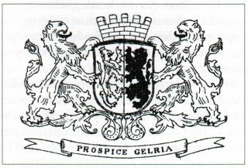

Colin Gallup

Director

Town of Guilderland

Parks & Recreation Department

181 Route 146

Altamont, NY 12009

518-456-3150

Peter G. Barber

Supervisor